Trello agent in Innometrics system documentation

Agent`s purpose is collecting activity from trello board. Here is the overall structure of a microservice. It consists of Services - for Action, Board and main service - TrelloService. There are also 2 entities Action and Board, that are tables of our database. TrelloController is the endpoint of our agent.

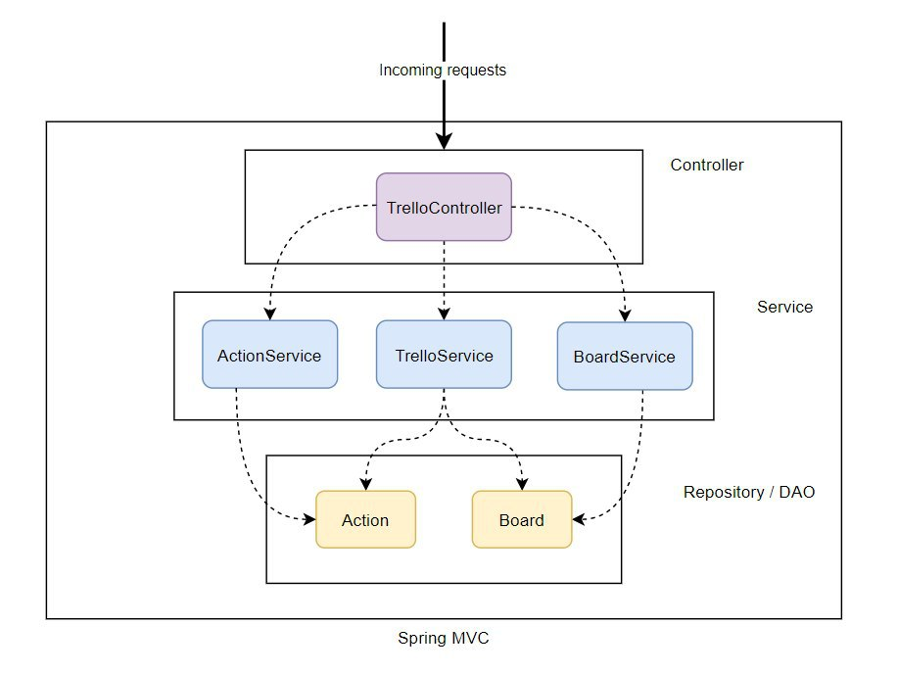

# Data flow diagram

## 

## 

# 

# How to start working with a system

First of all, you need to configure environmental settings in docker-compose.yml and put there your **HOST_IP** and **DB_HOST_IP.**

After configuring and successful deploy, you can use swagger documentation via standard API ( *YOUR_HOST_IP/swagger-ui.html* ) to see what actions you could do.

### The order of a connecting it to a project the following:

Firstly, you can get list of all boards. But also you can start with the next step.



Method collects all actions from given board and connects webhook for it to listen all future actions.



**IMPORTANT:**

boardUrl should be send in such way: only highlighted part

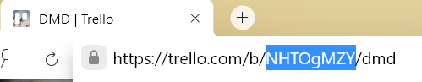

### To stop listening actions on particular board:

This will delete a webhook and all future actions on that board will not be collected



# Description of other API requests

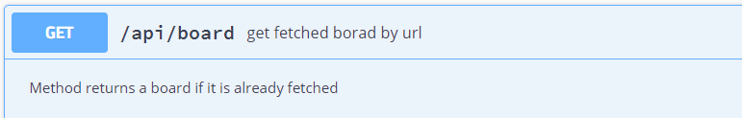

If you want to get a board that is already in DB. If the board by this Url is not fetched, message **"invalid board url"** will be raised.

In successful case Board object will be returned

|  |  |  |
| --- | --- | --- |
| "boardId" | "string" | Unique id that is used for all internal calls to Trello Server |
| "boardUrl" | "string" | Unique Url that is entered by user |
| "key" | "string", | Unique pair for authentication |
| "token" | "string" |
| "name" | "string", | Name of the board |
| "webhook" | boolean | Shows is the webhook set to the board or not |

{

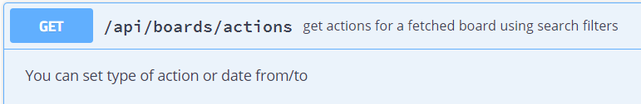

Returns list of actions. Action object is following:

|  |  |  |
| --- | --- | --- |
| actionId | "string" | unique id of action |
| attachmentId | "string" | unique id of attachment |
| attachmentName | "string" | name of attachment |
| boardId | "string" | unique id of board on which action occurred |
| boardName | "string" | name of board on which action occurred |
| cardClosed | "string" | true / false - active card or not |
| cardId | "string" | unique id of card on which action occurred |
| cardName | "string" | name of card on which action occurred |
| checkItemId | "string" | unique id of check item |
| checkItemName | "string" | name of check item |
| checkItemState | "string" | state of check item |
| checkListId | "string" | unique id of check list |
| checkListName | "string" | name of check list |
| date | "string" | date when action occured |
| emailMemberCreator | "string" | email of creator of an action |
| idMemberCreator | "string" | unique id of creator of an action |
| listAfterId | "string" | unique id of next list to current |
| listAfterName | "string" | name of next list to current |
| listBeforeId | "string" | unique id of previous list of current |
| listBeforeName | "string" | name of previous list of current |
| listId | "string" | unique id of list on which action occurred |
| listName | "string" | name of list on which action occurred |
| memberAddedDeletedId | "string" | unique id of added member |
| memberAddedDeletedName | "string" | name of added member |
| memberCreatorUsername | "string" | name of member created an action |
| pluginId | "string" | unique id of plugin set/removed |
| pluginName | "string" | name of plugin set/removed |
| pluginUrl | "string" | url of plugin set/removed |
| type | "string" | type of an action |

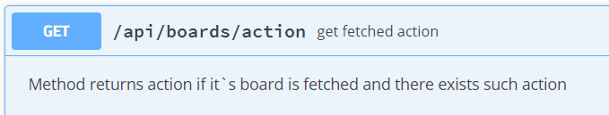

Get a particular action by its id ( *ActionId )*

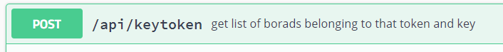

|  |  |  |
| --- | --- | --- |
| "boardId" | "string" | Unique id that is used for all internal calls to Trello Server |
| "boardUrl" | "string" | Unique Url that is entered by user |
| "key" | "string", | Unique pair for authentication |
| "token" | "string" |
| "name" | "string", | Name of the board |
| "webhook" | boolean | Shows is the webhook set to the board or not |

{

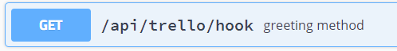

method responding to trello server

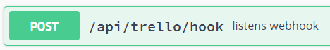

this method gets JSON from Trello server in such format:

## [**Example Webhook Response**](https://developer.atlassian.com/cloud/trello/guides/rest-api/webhooks/#example-webhook-response)

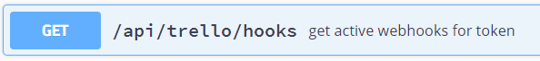

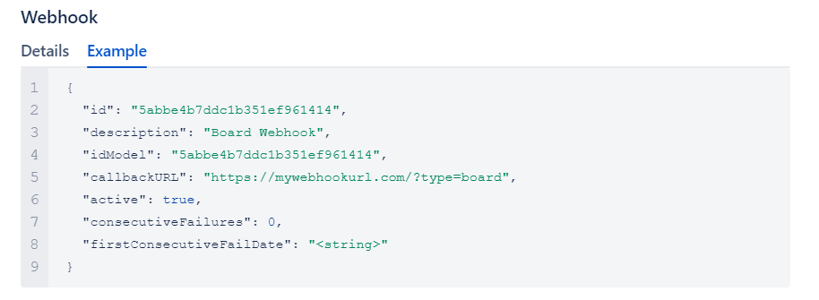

id - is unique identifier of a webhook

idModel - id of a board on which webhook set up

callbackUrl - url to which trello server sends actions when webhook is triggered